Government College Alewa
National Service Scheme Unit-315
Annual Activity Report
Session 2022-23
Sr.no. | Name of Activity | Organizing Unit/agency  Collaboration agency | Date of Implementation | No. of NSS Volunteers | Name of Agencies/consultant involved with contact details (if any)
1. | Tree Plantation drive by NSS Volunteers in GC Alewa Campus on (08-07-2022) under Aazadi ka Amrit Mahotsav. | National Service Scheme Unit-315  GC Alewa and Environment Committee  GC Alewa | 08-07-2022  To  14-07-2022 | 82 | 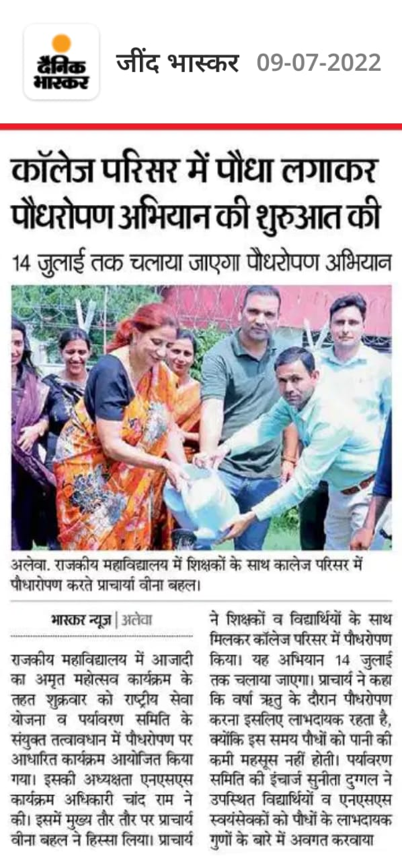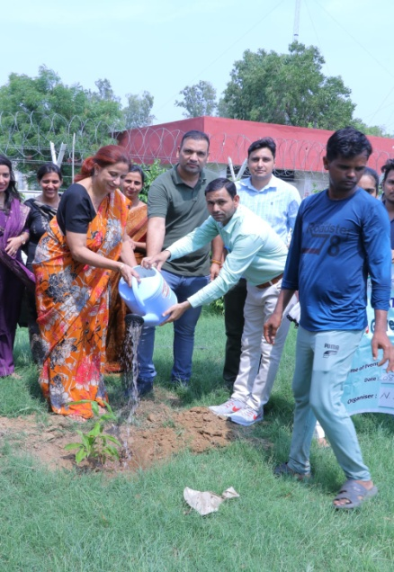
2. | Following activities are organized by NSS Volunteers Under Har Ghar Tiranga Abhiyan and Aazadi ka Amrit Mahotsav.  1. Poster making Competition Har Ghar Tiranga on (12-08-2022)  2. Rangoli Competition on Har Ghar Tiranga  On (12-08-2022)  3. Quiz Competition Tiranga and National Freedom Movement  On (13-08-2022) | National Service Scheme Unit-315  GC Alewa  And  Important Days Celebration Committee GC Alewa | 11-08-2022  to  14-08-2022 | 70 | 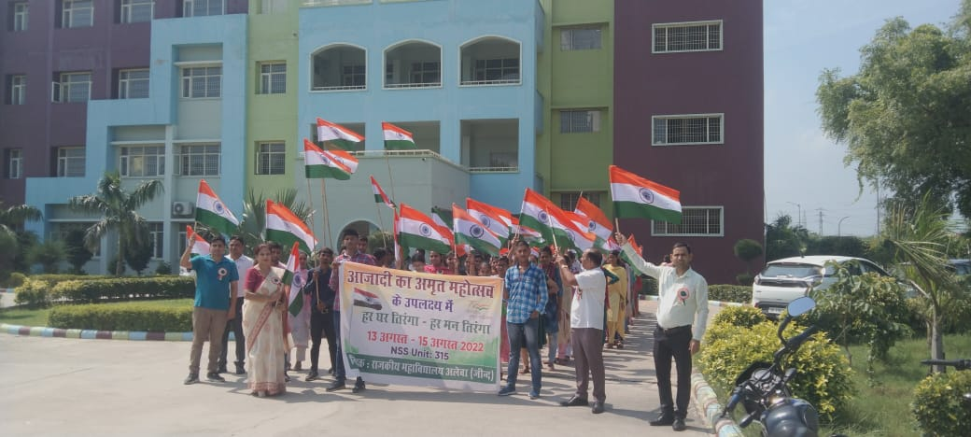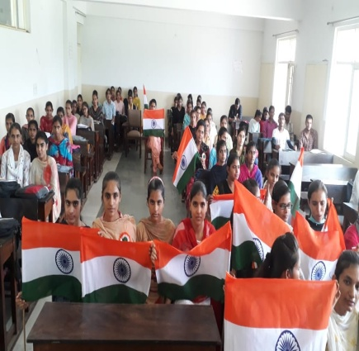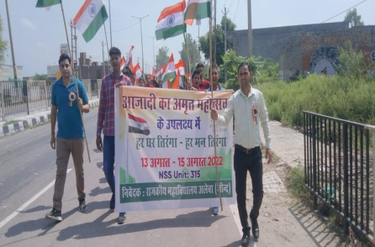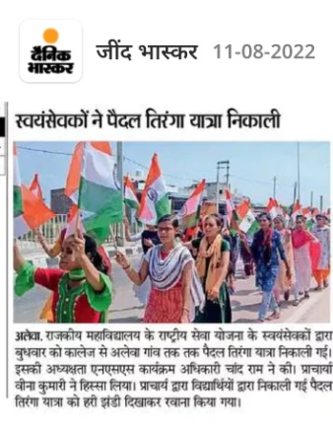
3. | Celebration of Foundation Day of National Service Scheme and Awareness Lecture given Sh. Chandram NSS PO GC Alewa to Motivate NSS Volunteers to serve Nation and Society on 24-09-2022 | National Service Scheme Unit-315  GC Alewa | 24-09-2022 | 60 | 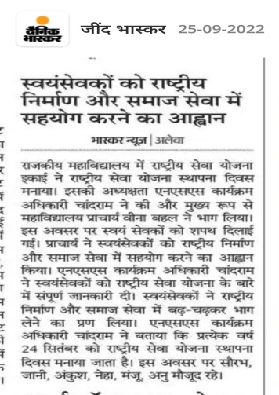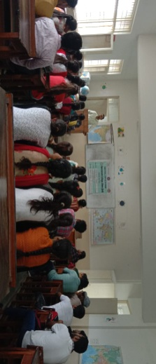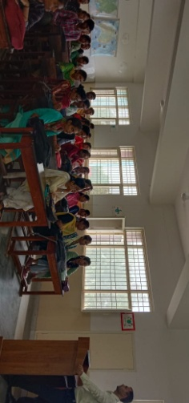
4. | NSS Volunteers of GC Alewa organized following activities under Poshan Pakhwada September 2022 programme  1. Poster making Competition on Poshan Aahar 27-09-2022  2. Slogan writing competition Poshan Aahar 27-09-2022  3. Quiz Competition on Poshan Aahar on 28-09-2022  4. Awareness Rally on Poshan Aahar on 28-09-22 | National Service Scheme Unit-315  GC Alewa | 27-09-2022  to  28-09-2022 | 80 | 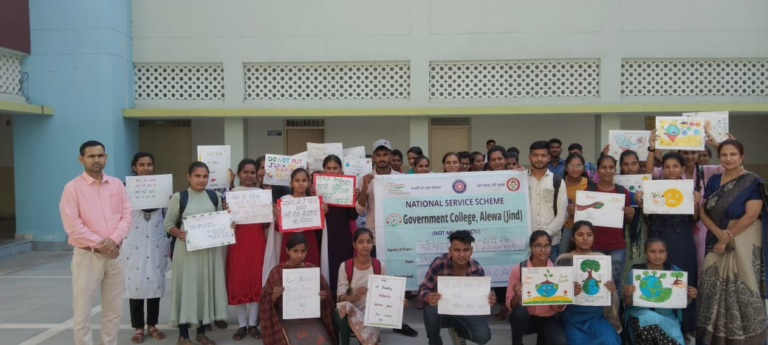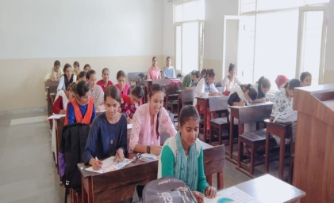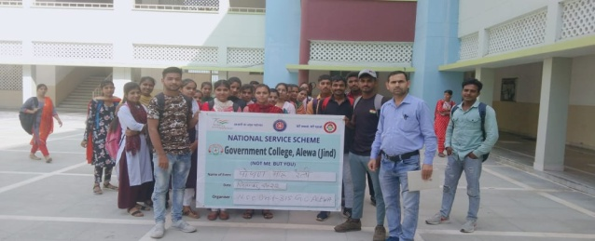
5. | Swachchh Bharat Abhiyan 2.0 was launched on 12-10-2022 in the month of October 2022 by NSS Unit 315 in Government College Alewa. National Service Scheme volunteers conducted a cleanliness campaign in the premises of College and explained the importance of cleanliness to other students and People. | National Service Scheme Unit-315  GC Alewa | 12-10-2022 | 70 | 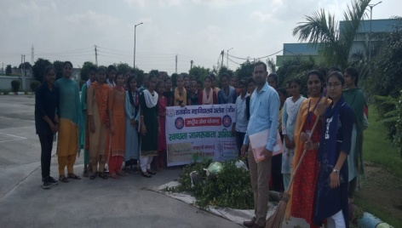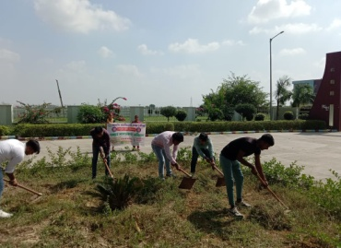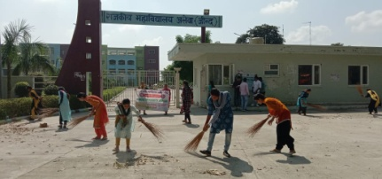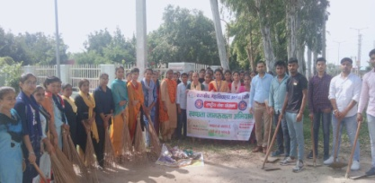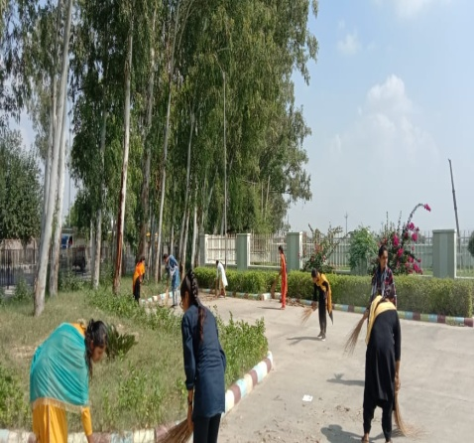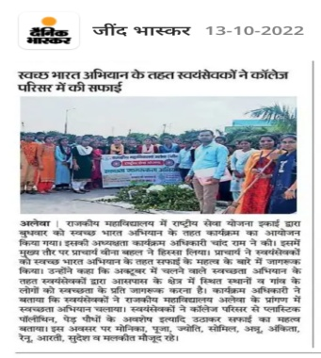
6. | Cleanliness drive run by NSS volunteers in Girls Hostel GC College on 12-11-2022 under Swachchhta abhiyan | National Service Scheme Unit-315  GC Alewa | 12-11-2022 | 60 | 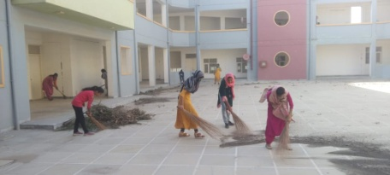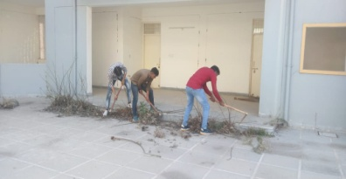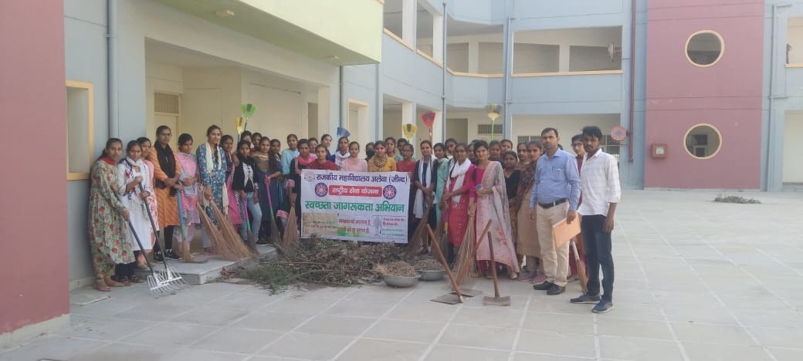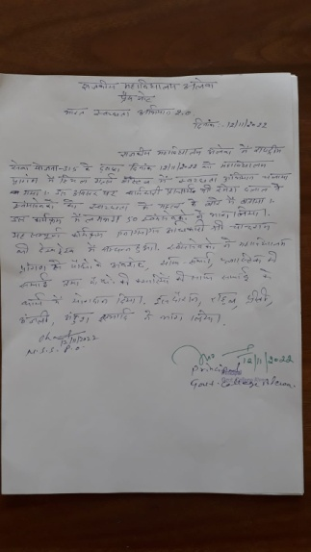
7. | Organized awareness rally by NSS Volunteers on 16-11-2022 Prali Nhi Jlayenge. | National Service Scheme Unit-315  GC Alewa | 16-11-2022 | 70 | 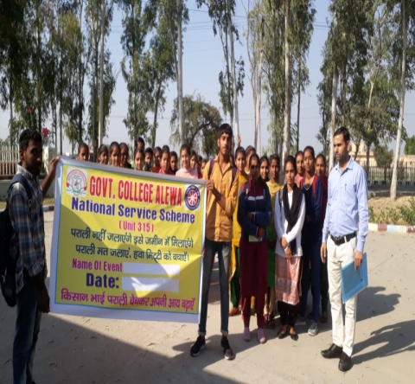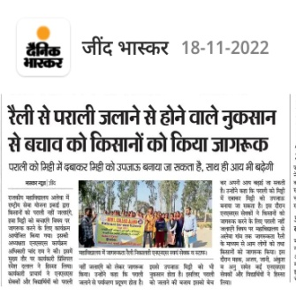
8. | NSS Unit-315 GC Alewa organized NSS One day Camp under Sawachchh Bharat Abhiyan on 20-11-2022 surrounding areas of College Campus and Girls Hostel GC Alewa. In NSS one day camp volunteers cleaned surrounding areas of College Campus and Girls Hostel and organized an awareness rally on under Sawachchh Bharat Abhiyan on 20-11-2022 in Alewa Village. | National Service Scheme Unit-315  GC Alewa | 20-11-2022 | 60 | 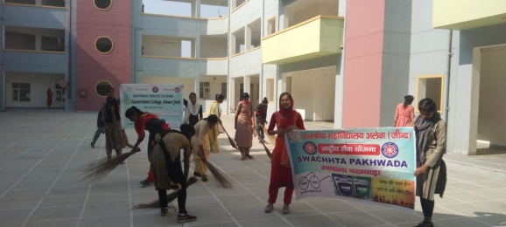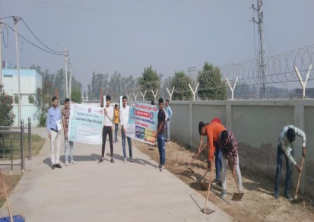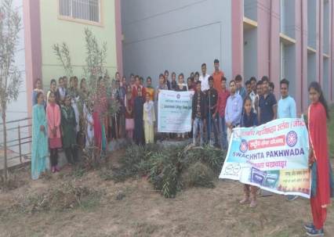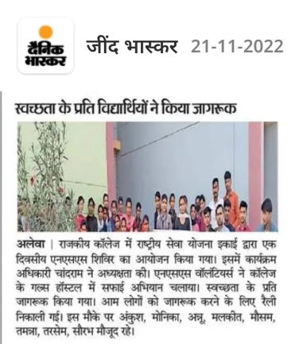
9. | Celebrated the Constitution Day of Indian Constitution on 26-11-2022 by NSS Volunteers and Students of GC Alewa. On this occasion Volunteers and Student Participate in following Activities.  1. Take Constitution Pledge.  2. Lecture Competition on Indian Constitution.  3. Quiz Competition on Indian Constitution  4. Read the Preamble of Indian Constitution. | National Service Scheme Unit-315  GC Alewa  And Dept. of Public Administration, Important Days Celebration Committee, Legal Literacy Cell GC Alewa | 26-11-2022 | 80 | 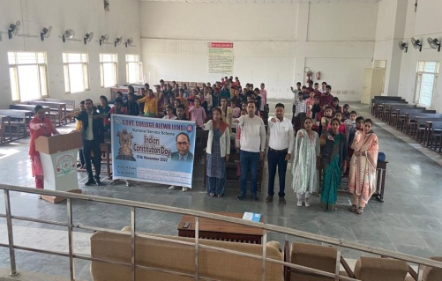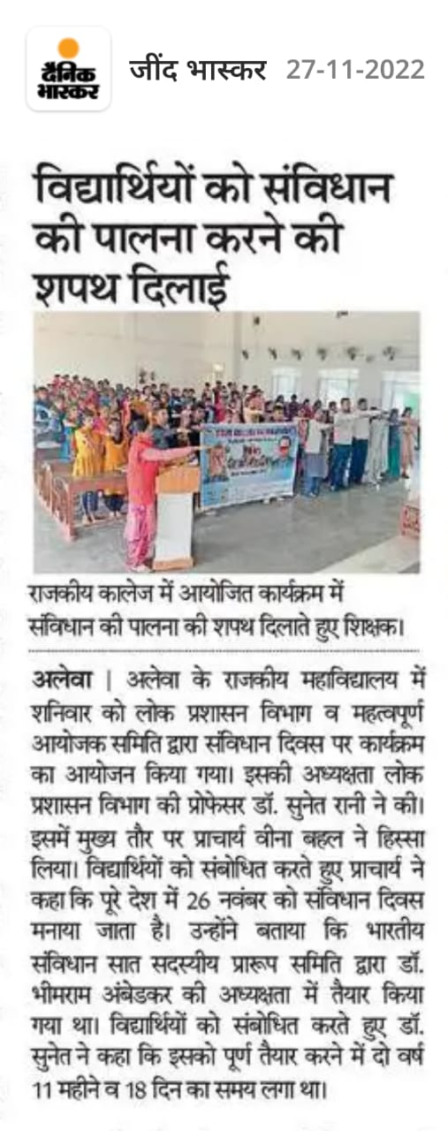
10. | NSS unit 315 and Red ribbon club GC Alewa organized an awareness rally about the preventing methods from AIDS diseases on 01-12-2022 from college campus to bus stand Alewa village. | National Service Scheme Unit-315  GC Alewa and Red Ribbon Club GC Alewa | 01-12-2022 | 60 | 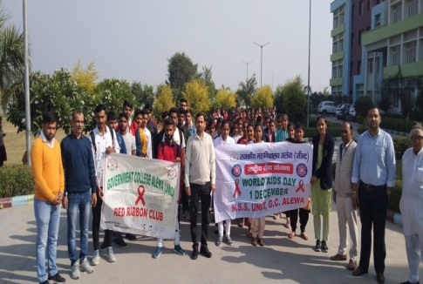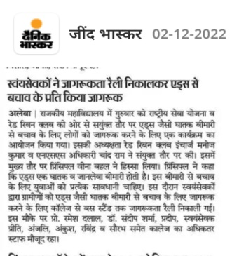
11. | Free health checkup camp with CHC Alewa organized in GC Alewa. An extension lecture/ awareness lecture about PCOD / PCOS menstruation and were organized in the college auditorium on 03/12/2022. | National Service Scheme Unit-315  GC Alewa and Women Cell, Youth Red Cross Cell and Red Ribbon Club GC Alewa in collaboration with Community Health Center, Alewa. | 03-12-2022 | 80 | 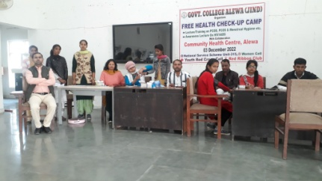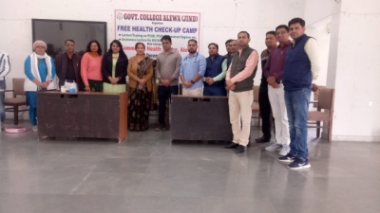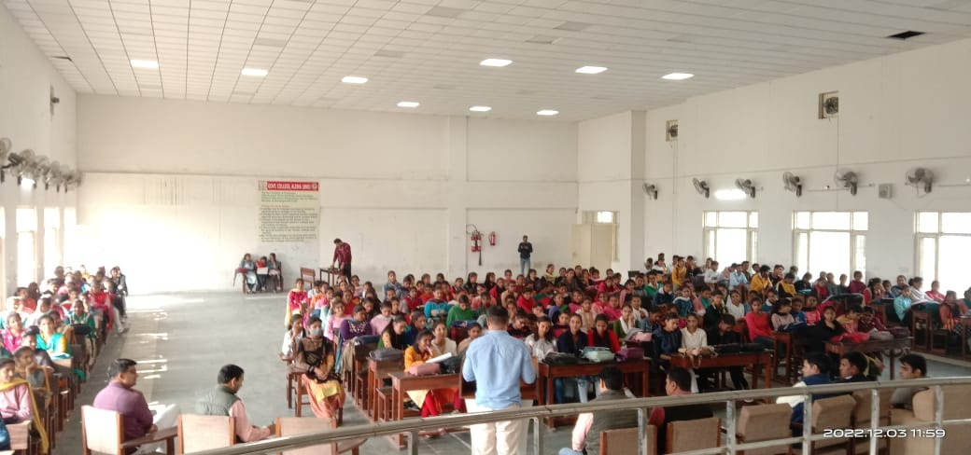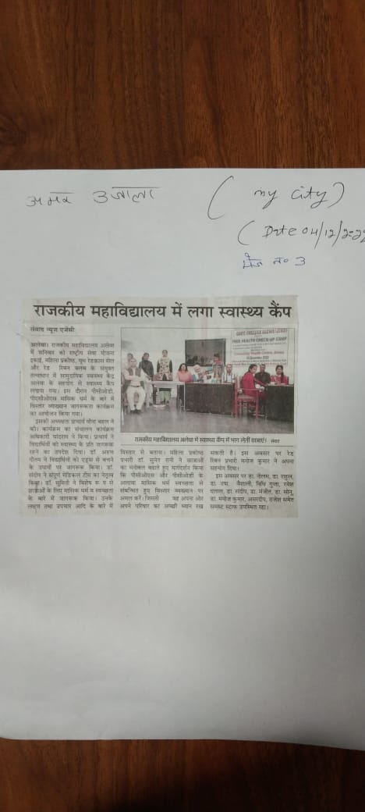
12. | Voter's Day was celebrated on 25 January 2022 in Government College Alewa. In this program, all the staff members, students took the voter's oath to vote during the elections. Through this program, the students were told that all those who are 18 years of age or above should get their votes registered and must vote during the elections. | National Service Scheme Unit-315  GC Alewa  And Voter ID Card Committee, Important Day Organizing Committee GC Alewa | 25-01-2023 | 60 | 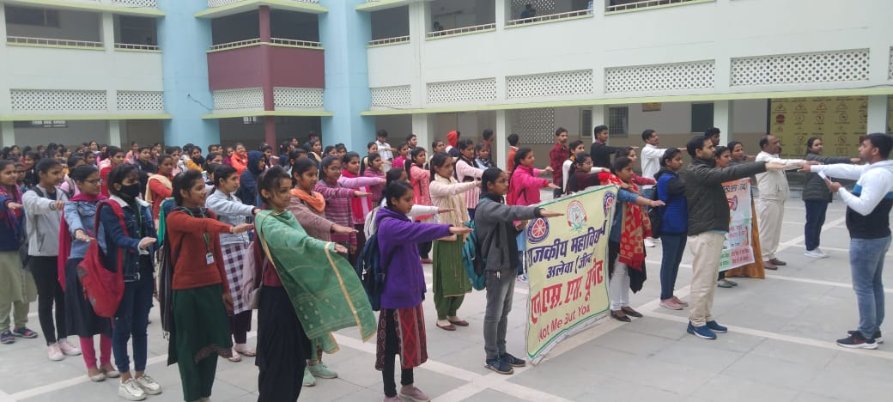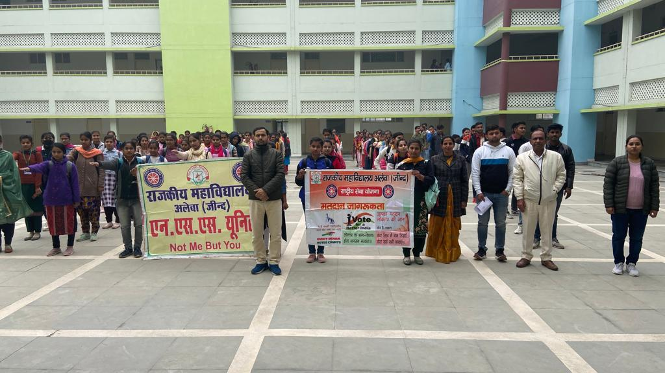
13. | On the occasion of World Cancer Day on 4th February 2023, an extension lecture was organized at Government College Alewa in collaboration with Community Center Alewa to spread awareness about the measures to prevent epidemics like cancer. Medical Officer Dr. Sandeep CHC Alewa gave awareness speech on topics related to cancer disease. | National Service Scheme Unit-315  GC Alewa and Important Day Organizing Committee, Red Cross Cell, Red Ribbon Club and Anti Tobacco Committee GC Alewa and Community Health Center, Alewa | 04-02-2022 | 70 | 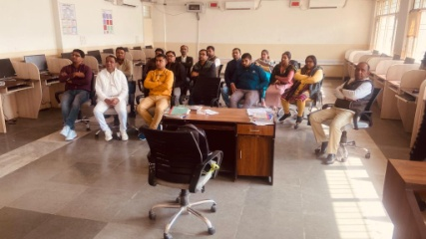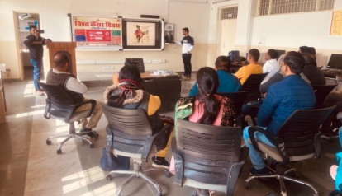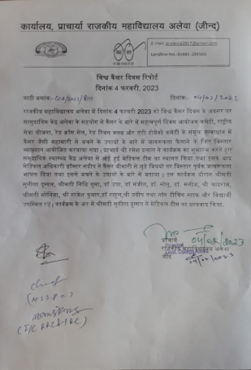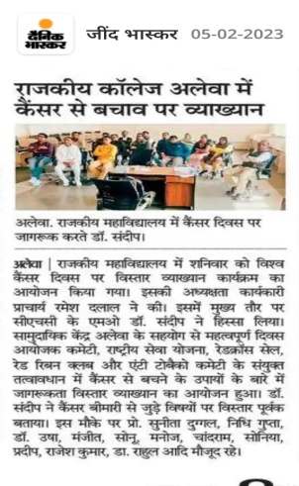
14. | National Service Scheme Unit 315, Government College Alewa organized a seven-day special NSS camp in Alewa village from 18/3/2023 to 25/3/2022. During this camp, the volunteers were made aware on topics like plantation campaign, environmental protection, Beti Bachao Beti Padhao, drug free campaign, plastic free India and water conservation, healthy India campaign, service to the elderly, digital India Under theme of Aatm Nirbhar Bharat etc. and awareness campaigns related to other topics were run. During this camp, the volunteers were motivated to always be ready to serve the nation and society. | National Service Scheme Unit-315  GC Alewa | 18-03-2022 to  25-03-2022 | 54 | 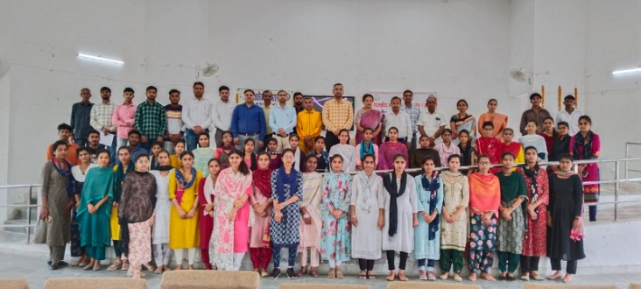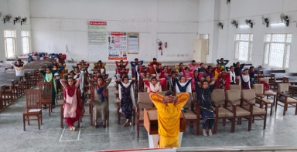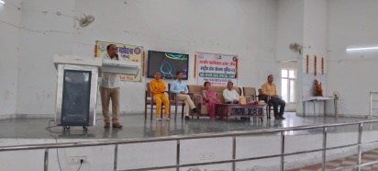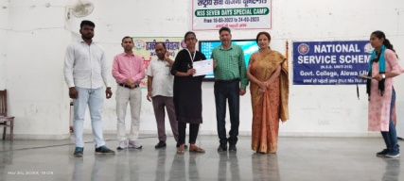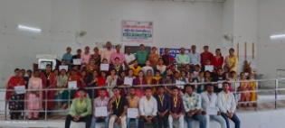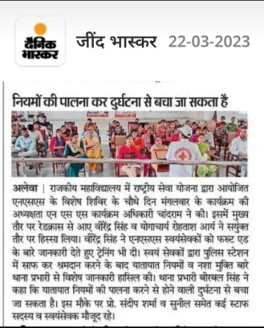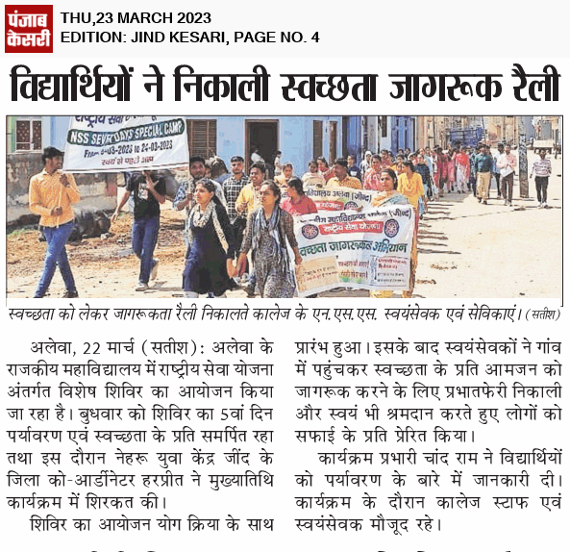
15. | An extension lecture given by Dr. Manoj AP Math GC Alewa on World Health Day on 7th April 2023 organized by NSS, RC and RRC in GC Alewa. | National Service Scheme Unit-315  GC Alewa and Red Ribbon Club and Red Cross, GC Alewa | 07-04-2023 | 50 | 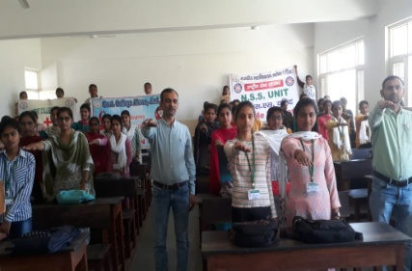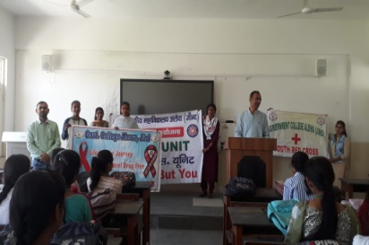
16. | An extension lecture program was organized in the college auditorium by the NSS Unit 315, Important Day Organizing Committee and History Department of GC Alewa on 13 April 2023 in the memory of Jallianwala Bagh martyrs and on the birth anniversary celebrations of Dr. Bhimrao Ambedkar. Mr. Ramesh Dalal Ji, | National Service Scheme Unit-315  GC Alewa and Important Day Organizing Committee and History Department of GC Alewa | 14-04-2023 | 80 | 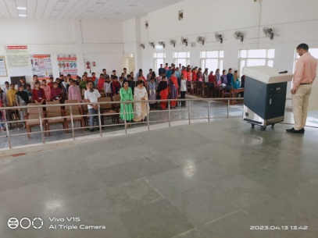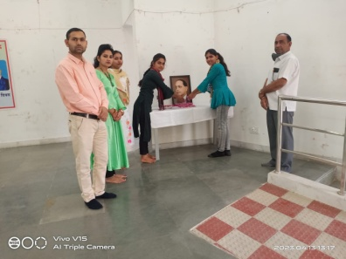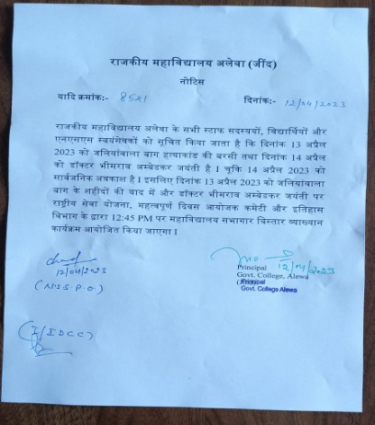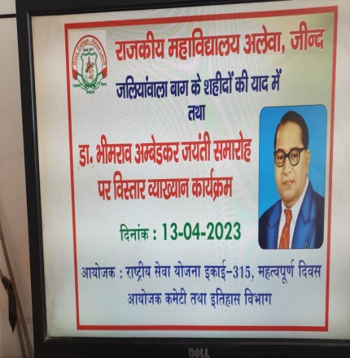
17. | On the occasion of Earth Day on 21 April 2023, National Service Scheme, Geography Department Society and Environment Committee GC Alewa organized programs like plantation and group discussion on climate change in Government College Alewa. | National Service Scheme Unit-315  GC Alewa and Geography Department Society and Environment Committee GC Alewa | 21-04-2023 | 70 | 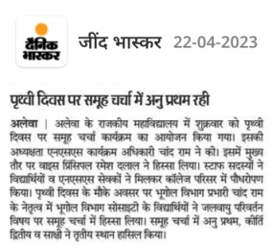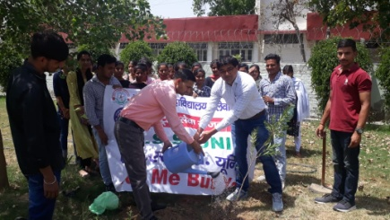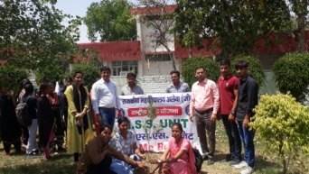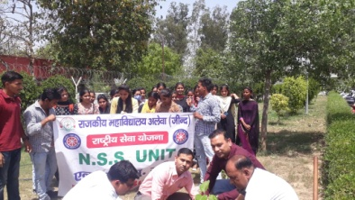
18. | World Bicycle Day was celebrated by National Service Scheme and Geography Department GC Alewa on 03-06-2023. On the occasion of World Bicycle Day, NSS volunteers organized a bicycle awareness rally. | National Service Scheme Unit-315  GC Alewa and Geography Department GC Alewa | 03-06-2023 | 40 | 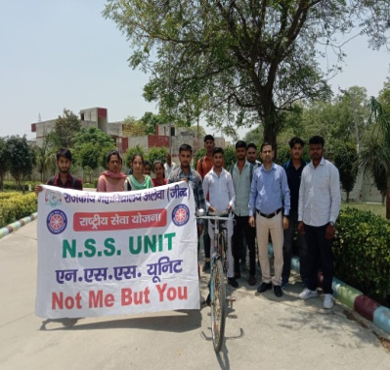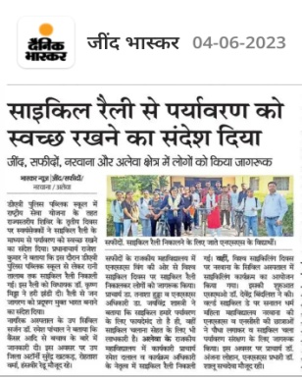
19. | World Environment Day was celebrated under Life Environment Mission by National Service Scheme, Environment Committee and Geography Department on 05-06-2023. | National Service Scheme Unit-315  GC Alewa and Environment Committee and Geography Department GC Alewa | 05-06-2023 | 50 | 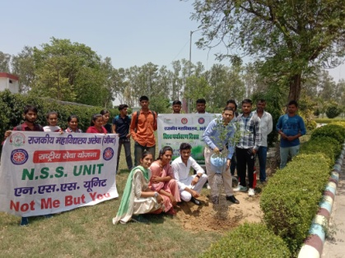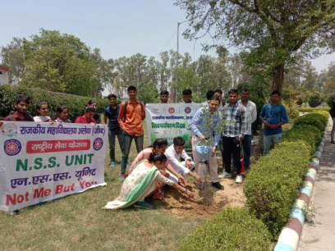
20. | In Government College Alewa, National Service Scheme and Important Day Organizing Committee organized a yoga program on the occasion of World Yoga Day on 21st June 2023 in the college premises. Everyone learned about the importance of yoga. | National Service Scheme Unit-315  GC Alewa and Important Day Organizing Committee, GC Alewa | 21-06-2023 | 80 | 